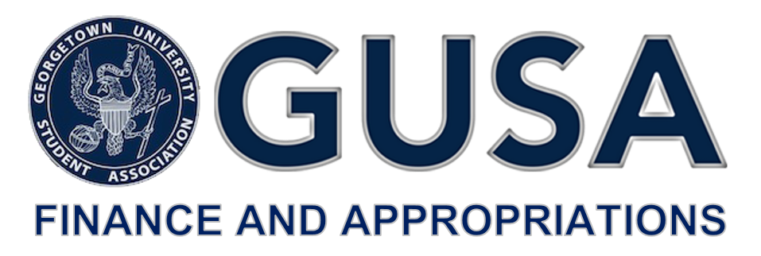

Dear Georgetown University Community,

As Beyonce once said, of course it goes down when there’s a million dollars on the elevator. Or something like that.

The time has come to once again convene the annual Budget Summit to allocate the Student Activities Fee among those entities on campus that enrich the lives of undergraduate students beyond their academic endeavors.

The Summit will be held on February 24th, 2018 beginning at 9 A.M.

The several Advisory Boards (ABCS, CAB, CMSF, CSJ-ABSO, Media Board, PAAC, SAC), GPB, Lecture Fund, and the GUSA Executive-Elect are guaranteed a presentation at the Summit (dabs) provided an application is submitted (converts to mini-dab).

Groups that do not fall within the aforementioned collective and are not supported by one of the Advisory Boards are eligible to submit an application for funding that will be reviewed by the Committee. If the application is accepted the admitted entity will be assigned an Adjunct Committee Member to assist with any preparation leading up to the Summit.

All applications are due no later than February 13th, 2018 at 5 PM. Applications submitted at 5:01 PM or later will not be reviewed ([please follow this link for application access](https://drive.google.com/drive/folders/1yRYvTRYfbBl088yn4vdwmw1hCtISwI92?usp=sharing)).

Office hours will be held for applicants on February 5th at 6 P.M. and on February 7th at 6 P.M. in the GUSA Office. If you plan to attend office hours please email [gusafinanceandappropriations@gmail.com](mailto:gusafinanceandappropriations@gmail.com) so that the Committee might be appropriately prepared to provide assistance.

This year the Committee has implemented reforms to increase the equitability and accuracy of the allocation process. Chief among them is expanded membership and the new requirement that all groups submitting an application must review the information in a joint meeting between the requesting entity’s leadership, relevant University advisor(s), and a member of the Committee. More details will be provided once submitted applications are approved.

We in the Committee look forward to working with each applicant throughout this process; please direct any questions to [gusafinanceandappropriations@gmail.com](mailto:gusafinanceandappropriations@gmail.com) with Assistant Dean for Student Affairs Erika Cohen Derr cc’d at [Erika.Cohen@georgetown.edu](mailto:Erika.Cohen@georgetown.edu).

To the Summit goes the Glory,

Christopher S. Holshouser

Chair, GUSA Finance and Appropriations Committee